Installation:
Copy the file to the \BIN folder and register it

regsvr32 protolog.dll

You should receive the following pop-up

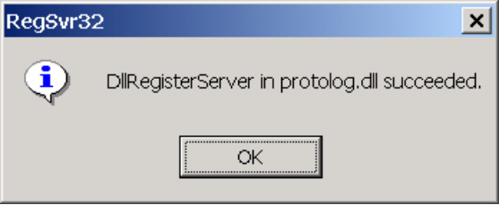

Enabling Logging:
The SMTP logging level is determined by the SMTP Protocol option under MSExchangeTransport Diagnostic Logging.

